Blackberry

Lodge #359

Trestleboard
March 2007
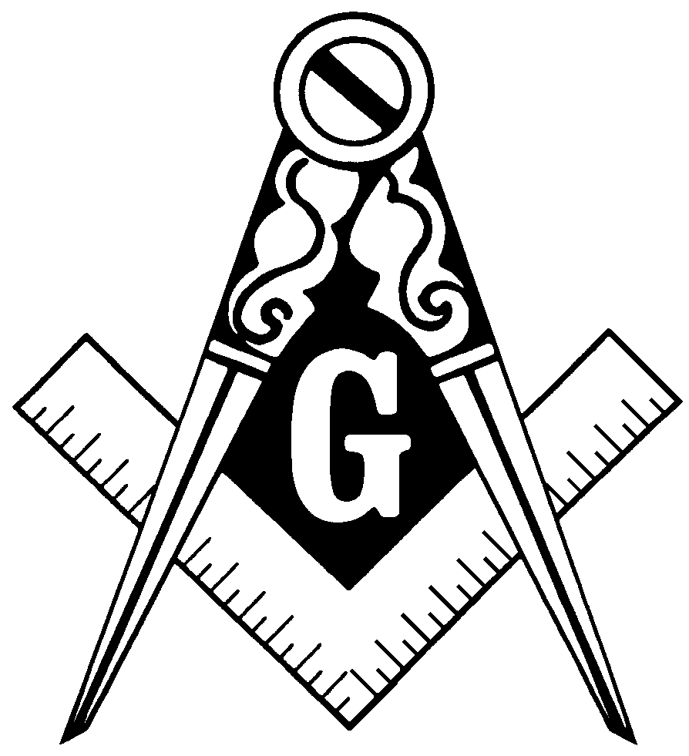

From the EasT

Dear Brethren,

As you all know on our meeting for January 13, 2007 we were going to have two new candidates, had to be cancelled because of bad weather.

We got together by phone and set-up a special meeting for February 21, 2007 by making some phone calls and sending out notices. We received help for the degree work from our neighboring lodges (I am quite thankful for that). Our two new Entered Apprentices are John Anthony Lasurdo and Frederick P. Neslund Jr.

Our lodge is trying to set-up a Blue Lighting for late March to mid April for all three of our Entered Apprentice. Also we have a new Plural Member Petition to vote on at our March 13th meeting for David Hughes.

Hope to see you all at the March meeting.

Fraternally,

Paul Thorne, WM

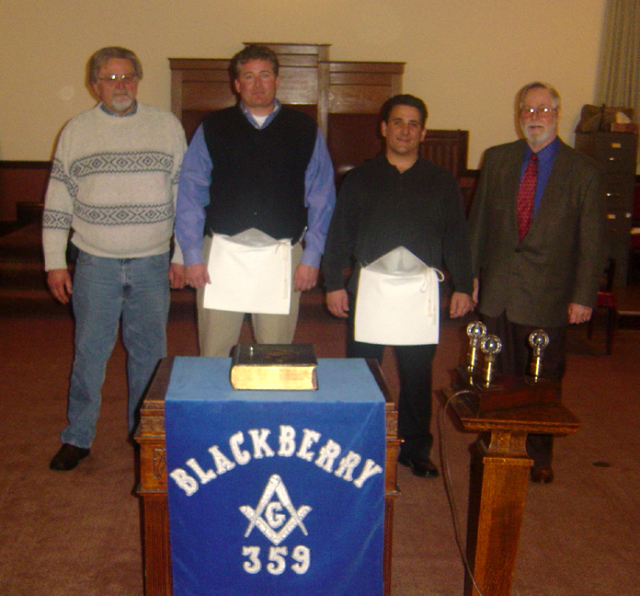

Installation Tuesday, February 27, 2007.
(L to R) Fred Neslund Sr., Fred Neslund Jr., John Lasurdo, and Paul Thorne WM.

Masonic Anniversaries

The following brothers celebrate being Raised to the sublime degree of Master Mason in March. Congratulations to all of you!

David Bateman | 3/13/1962 | 45 Years
Charles L. Hokonson | 3/31/1964 | 43 Years
Charlie Tennant | 3/18/1975 | 32 Years
Billy Adamson | 3/30/1976 | 31 Years
Joseph Q. Sikon | 3/1/1982 | 25 Years
Frederick C. Neslund | 3/11/1986 | 21 Years
George R. Jackson | 3/1/1988 | 19 Years

LIFE IS FOR LIVING

Life is a gift we're given each and every day.
Dream about tomorrow, but live for today.
To live a little, you've got to love a whole lot.
Love turns the ordinary into the extraordinary.
Life's a journey
always worth taking.
Take time to smell the roses... and tulips...
and daffodils... and lilacs... and sunflowers...
Count blessings like children count stars.
The secret of a happy life isn't buried in a
treasure chest... it lies within your heart.
It's the little moments that make life big.
Don't wait. Make memories today.
Celebrate your life!

~ Anonymous
Around the District

Blackberry Lodge #359 Stated Meeting, Tuesday, March 13 at 7:30 p.m.

Fox Valley Order of the Eastern Star – Meetings on 2nd & 4th Tuesdays

Every Sunday, 11:00 a.m., Cook-Lombardi-Duck School of Masonic Instruction,
at Downers Grove Masonic Temple

DAY | DATE | TIME | WHERE | LODGE | ACTIVITY
Tuesday | 3/6 | 7:00 PM | Geneva | Geneva 139 | 2 - 1st Degrees
Wednesday | 3/7 | 7:30 PM | Yorkville | Aurora Commandry | Stated Meeting
Thursday | 3/8 | 4:30 PM | Medinah | Scottish Rite | Wardens Dinner
Thursday | 3/8 | 7:30 PM | Geneva | Chapter/Council | Stated Meeting
Saturday | 3/10 | 7:30 AM | Geneva | Colonial Rest. | Wardens Breakfast
Monday | 3/12 | 7:00 PM | Geneva | Elgin 117 | Official Visit
Monday | 3/12 | 7:30 PM | Batavia | Batavia 404 | Stated Meeting
Tuesday | 3/13 | 7:30 PM | Elburn | Blackberry 359 | Official Visit
Thursday | 3/15 | 7:30 PM | Geneva | Unity 48 | Official Visit
Tuesday | 3/20 | 7:30 PM | Geneva | Geneva 139 | Official Visit
Thursday | 3/22 | 6:30 PM | Elburn | Blackberry 359 | Standard Club 2nd Degree
Friday | 3/23 | 6:00 PM | Elmhurst | Diplomat West | Master's Dinner Dance
Sunday | 3/25 | 7:00 PM | Batavia | Batavia 404 | Pancake Breakfast
Monday | 3/26 | 7:30 PM | Batavia | Batavia 404 | Official Visit
Wednesday | 3/28 | 7:30 PM | Cary | Calvary Commandry | Stated Meeting

Officers List 2006
WM | Paul Thorne | 630-365-6217
SW | Eric Sanders | 630-782-0660
JW | Charles Capes | 630-365-2856
TR | Bob Armstrong | 815-459-3898
SEC | David Capes | 815-784-6626
CH | Sam Beirger | 630-879-8540
SD | Tim Ward | 630-510-7663
JD | Dean Capes | 630-365-6219
SS | Percy Meredith | 630-365-6138
JS | Lee Felski | 630-761-1891
M | Ralph Conley | 630-232-4073
TY | Dave Vaughan | 815-286-7893

