Blackberry

Lodge #359

Trestleboard
January 2007
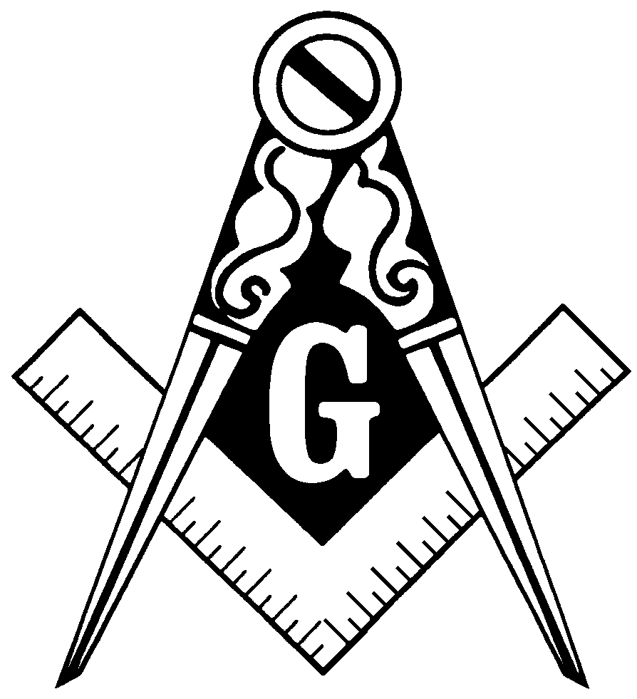

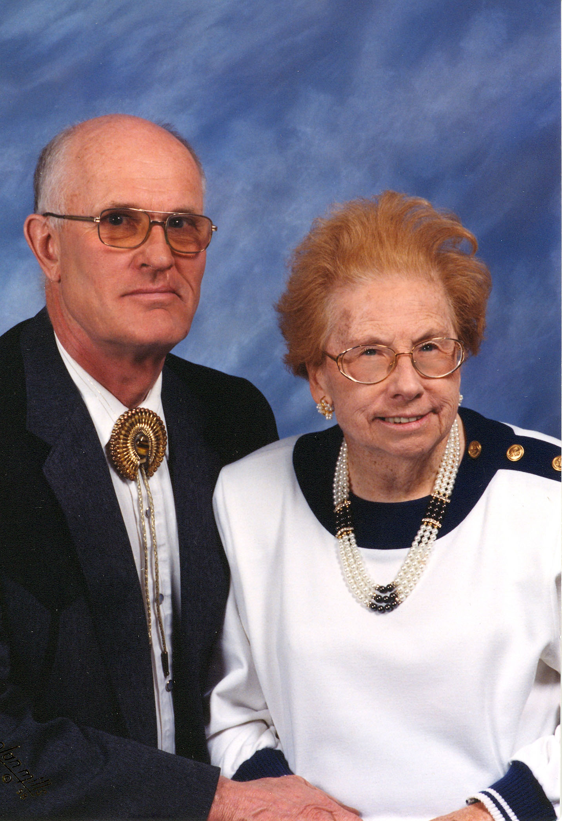

CharleS & Caroline Capes
Charlie & Caroline Capes

We open this Trestleboard with a hope for comfort and strength for our Brother Charlie Capes and his family. Charlie had a brain aneurysm in late November and is now recovering at the Marianjoy Rehabilitation Hospital in Wheaton. He’s doing much better, but could use more visitors. Then on December 27th, his wife Caroline passed away. Her obituary appears below. Please include the Capes family in your thoughts and prayers, and go visit Charlie when you can.

Caroline Capes’ Obituary

Caroline L. Capes, age 87, of Maple Park, IL, passed away peacefully Wednesday evening, December 27, 2006, at Rosewood Care Center, St. Charles, where she had recently become a patient. Though Alzheimers Disease kept her captive for
many years, Caroline was never alone for she was surrounded by her loving family and safe in her Savior’s keeping. Now, she is free and “home” at last in Heaven.
She was born March 6, 1919, in Geneva, IL, daughter of Fred Harold and Sigrid Dagmar (Bakken) Swanson. She attended Geneva High School and graduated with the class of 1936. For a time, she worked at Montgomery Wards in Chicago. Later, she was employed as an administrative assistant for the Chicago, Title and Trust Company, Geneva and retired after twenty-five years.
In 1965, two friends became man and wife when Caroline was united in marriage to Charles Capes on August 7, 1965. They became friends through their involvement in the Order of the Eastern Star and then as time went by a love blossomed and together with Charlie’s two daughters, they became a family. In March of 1970, they chose a son, Paul, and their family was complete. They made their home on the Capes family farm. In 1972, they built a new house which Caroline delighted in decorating, and have made their home there until the present time. At the age of eighteen, Caroline joined the Order of the Eastern Star at the Geneva Chapter #952; it would be the beginning of a lifetime commitment. In later years, she became a dual member with the Anemone Chapter #678 in Elburn. When it joined with the Fox Valley Chapter Caroline became a member there. She served as Instructress for Anemone Chapter and later for Fox Valley Chapter #265. She became involved with the DeKalb Order of Jobs Daughters, Bethel #66 when her daughters and her niece were members there. Later, she served as Guardian for Bethel #66.
In late 1970’s, Charlie began Capes and Son, Inc. and Caroline became his “girl Friday” running the office and working as his secretary. Their family raised, there was time to enjoy life together. Caroline and Charlie spent a number of years square dancing with the Sugar Squares and enjoyed traveling including their dream trip to Hawaii and Alaska. Caroline will be remembered for her loving service to others, friendly and generous nature, fierce loyalty to those close to her and her strength. Her gifts included spelling, memorization, hospitality and beautiful penmanship. She had a wonderful laugh, a love of nature and was devoted to her husband, children and grandchildren. When trials and illness came her way, faith sustained her. She was a member of the Kaneville United Methodist Church, Kaneville, IL.

She is survived by her devoted husband, Charles Capes of Maple Park, IL; her son, Paul (Christine) Capes of Elburn, IL; two daughters, Mary (Vern) Roberts of Wallis, TX and Carol (Bob) Praetorius of Boerne, TX; ten grandchildren: Crystal and Serena Berkes; Jessica (Erik) Finley and their daughter, Lily; Robert and Charles Praetorius; Bobbie ( Paul) Kokorowski and their daughter, Alison; Natasha, Savannah and Charles
Roland Capes, II and Justin Adkerson; her niece, Carol (Mike) Zars of St. Charles, IL; a number of other nieces and nephews and a lifetime of friends.
She is preceded in death by her parents; two sisters, Marie Swanson and Ethel Whitney; two nephews, Robert Capes and Thomas Whitney and one sister-in-law, Joanne Capes. Her visitation will be held Tuesday, January 2, 2007 from 4-8 p.m. at the Kaneville United Methodist Church, Kaneville with an Eastern Star Service to be held at 7:30 p.m. A funeral to celebrate her life will be held at 11am, Wednesday, January 3rd at the Kaneville United Methodist Church. Pastor Jason Turner,
pastor of the church will officiate and interment will follow at Blackberry Cemetery, Elburn. A memorial has been established in her name. Checks may be made to the Caroline Capes Memorial and mailed in care of P.O. Box 66, Elburn, IL 60119. Tributes and memories may also be forwarded to the family at that address or through www.conleycare.com.

Masonic Anniversaries

The following brothers celebrate being Raised to the sublime degree of Master Mason in December and January. Congratulations to all of you!

Johnnie F. Thomas | 12/17/1954 | 53 Years
Charles R. Capes | 1/11/1956 | 51 Years
Frances Jameson | 12/26/1956 | 50 Years
Donald L. Capes | 1/14/1961 | 46 Years
Eugene M. Capes | 1/14/1961 | 46 Years
Carl Dean Davison | 12/2/1968 | 39 Years
Lee J. Felski | 1/19/2002 | 5 Years
Jason Townsend | 1/19/2002 | 5 Years
Timothy J. Ward | 1/19/2002 | 5 Years

Around the District

Batavia Lodge – Meetings on 2nd & 4th Mondays
Dundee Lodge – Meetings on 1st & 3rd Thursdays
Elgin Lodge – Meeting on 2nd Monday
Geneva Lodge – Meeting on 1st & 3rd Tuesdays
Unity Lodge – Meetings on 1st & 3rd Thursdays
Fox Valley Order of the Eastern Star – Meetings on 2nd & 4th Tuesdays

From the EasT

Dear Brethren,

Thank you for electing me to serve in the East again. I hope that over the next year we can build some new strength in the Lodge, to keep it going for many years to come. It will require work and commitment from all of us, but will be well worth the effort.

When we discussed strategic planning several months ago, we listed many things we might do to strengthen the Lodge. I’ll list them again below. Let’s discuss them again at our next meeting, and choose our focus for the coming year. That will help us to enjoy our time together each month more, and of course, will make our Lodge stronger and more viable.

In the Lodge (formal Lodge work)
- Ritual well done
- Participate in Standard Club
- Give new members a job
- Younger brethren encourage and help each other
- Competitions
- Mentoring
- Masonic history presentations regularly

Social Events (Masons only)
- Fast meetings followed by social events
- Cards
- Eating and talking

Social Events (Masons and their families)
- Picnics with families
- Sporting events
- Theatre
- Dinners at Lodge at least once/month with brethren and their wives

Community Involvement
- Donate money and time to charities
- Donate poinsettias at Christmas time
- Scholarships
- Sponsor Little League teams
- Participate in blood drives

Marketing
- Tell our story
- Highlight our successes (and contributions to the community)
- Masonic business cards (or wooden nickels) passed out at events like parades
- Invitation to petition (to potential members)

See you at the Stated Meeting on Tuesday, January 9th.

Fraternally,

Paul Thorne, WM

Officers List 2006
WM | Paul Thorne | 630-365-6217
SW | Eric Sanders | 630-782-0660
JW | Charles Capes | 630-365-2856
TR | Bob Armstrong | 815-459-3898
SEC | David Capes | 815-784-6626
CH | Sam Beirger | 630-879-8540
SD | Tim Ward | 630-510-7663
JD | Dean Capes | 630-365-6219
SS | Percy Meredith | 630-365-6138
JS | Lee Felski | 630-761-1891
M | Ralph Conley | 630-232-4073
TY | Dave Vaughn | 815-286-7893

