Blackberry

Lodge #359

Trestleboard
February 2007
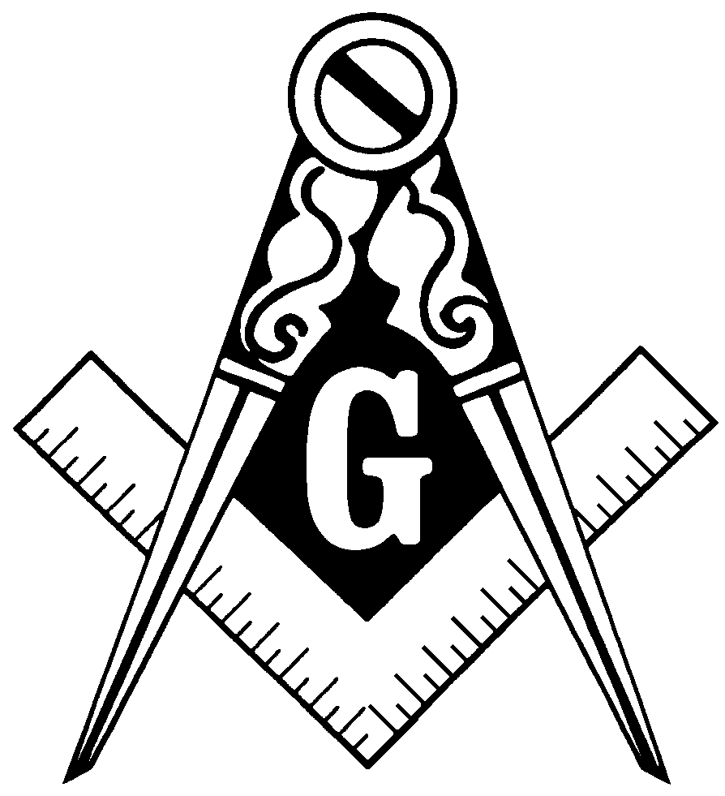

From the EasT

Dear Brethren,

We’re making progress in regaining momentum in our Lodge. We’ll initiate a new Entered Apprentice at our next Stated Meeting on Tuesday, February 13. We have another candidate whom we hope to initiate at a special meeting in late February, and have one who received his first degree last year, but is still waiting to advance in Masonry.

Sometime in March, we hope to organize a Blue Lightning for these three new Masons, plus any others who would like to join in that work.

Thanks to all of you who are making this possible. Keep up the good work, and help us make Blackberry strong for another century or more.

Fraternally,

Paul Thorne, WM

Thank God

If God brings you to it,
He will bring you through it.
Happy moments, praise God.
Difficult moments, seek God.
Quiet moments, worship God.
Painful moments, trust God.
Every moment, thank God.

~ Anonymous
Freedom Military Lodge # 1775

Freedom Military Lodge #1775 was Chartered last month as a regular Lodge under The Grand Lodge of the District of Columbia in Washington, DC. Our mission and purpose is to honor, support, and serve the members of the Uniformed Military Services.

The more members we have in more locations, the better we will be able to fulfill our mission. Therefore, will you please send this email out to your large address list? We have a web site at www.freedomlodge.org and welcome anyone interested in supporting our Military members to visit our site.

Fraternally,

Bill F. Greschel, WPM, LTC USA (Ret.)
Worshipful Master

Masonic Anniversaries

The following brothers celebrate being Raised to the sublime degree of Master Mason in February. Congratulations to all of you!

Walton Elliott | 2/25/1958 | 49 Years
Robert P. Armstrong | 2/3/1996 | 11 Years
Daniel D. Capes | 2/3/1996 | 11 Years
David D. Capes | 2/3/1996 | 11 Years
Paul B. Capes | 2/3/1996 | 11 Years

Around the District

Batavia Lodge – Meetings on 2nd & 4th Mondays
Dundee Lodge – Meetings on 1st & 3rd Thursdays
Elgin Lodge – Meeting on 2nd Monday
Geneva Lodge – Meeting on 1st & 3rd Tuesdays
Unity Lodge – Meetings on 1st & 3rd Thursdays
Fox Valley Order of the Eastern Star – Meetings on 2nd & 4th Tuesdays

Master’s and Warden’s Breakfast, 7:30 a.m., Saturday, Feb. 10.
Contact Dan Jones for details (630) 816-4567

Blackberry Lodge #359 Stated Meeting, Tuesday, February 13 at 7:30 p.m.
We will initiate a new Entered Apprentice at this meeting.

Every Sunday, 11:00 a.m., Cook-Lombardi-Duck School of Masonic Instruction,
at Downers Grove Masonic Temple

Batavia Lodge Pancake Breakfast, 7:30 a.m., Sunday, Feb. 25.

Calvary Commandry #25, 7:30 p.m., Wed. Feb. 28 at Cary Lodge

Officers List 2006
WM | Paul Thorne | 630-365-6217
SW | Eric Sanders | 630-782-0660
JW | Charles Capes | 630-365-2856
TR | Bob Armstrong | 815-459-3898
SEC | David Capes | 815-784-6626
CH | Sam Beirger | 630-879-8540
SD | Tim Ward | 630-510-7663
JD | Dean Capes | 630-365-6219
SS | Percy Meredith | 630-365-6138
JS | Lee Felski | 630-761-1891
M | Ralph Conley | 630-232-4073
TY | Dave Vaughan | 815-286-7893

