Blackberry

Lodge #359

Trestleboard
May 2007
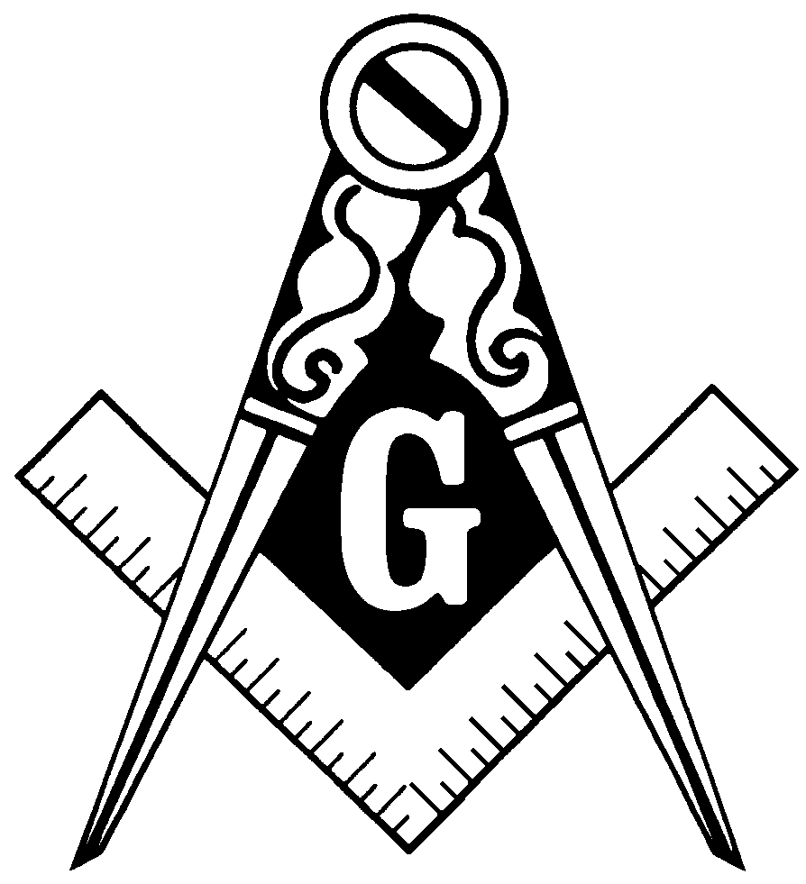

From the EasT

Dear Brethren,

We’ve made some tremendous strides in revitalizing our Lodge, and I want to thank all of you who have helped. Many more brethren are attending Lodge meetings, so we regularly have several sideliners at each meeting. That’s always pleasant. Those of you who have not attended recently should come join us.

We are gaining new members as well. Two new Master Masons received their degrees in the Blue Lightning held on Saturday, April 7, 2007. Please join me in welcoming John Losurdo and Fred Neslund Jr. to the Craft. We also have several new plural members who have joined our Lodge to help us work better, and are grateful for the help they provide.

Please continue to help further the work of making good me better. It’s not too early to think ahead to the roles you would like to play in our Lodge next year. Our new brethren will likely start up the chairs, but we will need experience officers to teach them and be examples for them. Let me know what you would like to do.

May Brotherly Love Prevail,

Paul Thorne, WM

Greeting from Arizona

by Brother Dean Capes, PM, 3/7/2007

I attended Green Valley Lodge No. 71, F & A.M. located at 18090 S La Canada, Sahuarita, Az. on two occasions. They had a regular meeting with 42 brothers present of which about 20 were past masters. One Brother was Master of his lodge in 1941. I know many of you are thinking WOW, how old is he. That was before most of us were born. The brother was and is 96 years young, looking good, able to see, hear, and communicate.

It is interesting to note the small differences between Illinois and Arizona work. Their name is not a typo, they are Free and Accepted Masons a slight difference from Illinois Ancient Free and Accepted Masons. I was able to attend lodge and see them put on a 1st Degree. Very Similar. It was great,

But "the best is yet to come".

On Saturday, March 3rd I joined 105 Brothers at a Festival held at Nogales Lodge No. 11, F.& A.M. in Nogales, Az. I was able to watch an Entered Apprentice be examined on his catechism and than the Nogales Lodge put on a Fellow Craft Degree Arizona Style. (Of Course)

They have Lodge every Wednesday at 8:00 PM and everyone is invited. Bring your dues card and they will let you attend. The lodge is a very short walking distance from the boarder crossing and is across the alley from the Border Wall. You can see the Masonic Square and Compass from the USA parking lot above the fence. You might need to brush up on your Spanish.

They have this type of Friendship Festival every year with both Lodges getting together putting on a degree in Nogales, Az and another degree in Nogales, Sonora, Mexico. Last year they had 180 brothers and this year attendance was down to 105.
I plan to attend next year. They had one charter bus come down from Phoenix with members of different lodges on board the bus.

Farewell from Warm and Sunny Arizona.

Officers List 2006
WM | Paul Thorne | 630-365-6217
SW | Eric Sanders | 630-782-0660
JW | Charles Capes | 630-365-2856
TR | Bob Armstrong | 815-459-3898
SEC | David Capes | 815-784-6626
CH | Sam Beiriger | 630-879-8540
SD | Tim Ward | 630-510-7663
JD | Dean Capes | 630-365-6219
SS | Percy Meredith | 630-365-6138
JS | Lee Felski | 630-761-1891
M | Ralph Conley | 630-232-4073
TY | Dave Vaughan | 815-286-7893

Masonry on Public TV & Radio

There was a very poor special on Freemasonry on PBS recently, and an excellent one on National Public Radio that aired Saturday, May 5th. The latter was titled “New Masons Drawn by Brotherhood, Not Myths” and talked about the new Masons who are joining the Craft, and the excitement they bring. Those of you with Internet access, check it out at:
http://www.npr.org/templates/story/story.php?storyId=9981492
Masonic Anniversaries

The following brothers celebrate being Raised to the sublime degree of Master Mason in April and May. Congratulations to all of you!

Name | Date Raised | How Many Years a Mason
Floyd P. Cleeson | 4/22/1947 | 60
Ralph E. Conley | 4/5/1951 | 56
Percy L. Meredith | 4/29/1952 | 55
James R. Thompson | 5/13/1943 | 64
Bernie L. Vogt | 4/3/1967 | 40
Paul H. Thorne | 5/31/1979 | 28
James L. Meredith | 5/25/1983 | 24
David W. Thorne | 5/28/1985 | 22
Kenneth D. Thorne | 5/28/1985 | 22
Geoffrey L. Capes | 4/4/1998 | 9
Geordan L. Capes | 4/4/1998 | 9
Eugene M. Capes II | 4/4/1998 | 9
Randy W. Stayner | 4/7/1998 | 9
Sam J. Beiriger | 4/6/2002 | 5
James A. Gaffney, JR. | 4/6/2002 | 5
David A. Vaughan | 4/6/2002 | 5

Around the District

Blackberry Lodge #359 Stated Meeting, Tuesday, May 8 at 7:30 p.m.

Batavia Lodge – Meetings on 2nd & 4th Mondays
Dundee Lodge – Meetings on 1st & 3rd Thursdays
Elgin Lodge – Meeting on 2nd Monday
Geneva Lodge – Meeting on 1st & 3rd Tuesdays
Unity Lodge – Meetings on 1st & 3rd Thursdays
Fox Valley Order of the Eastern Star – Meetings on 2nd & 4th Tuesdays

