[your address here]
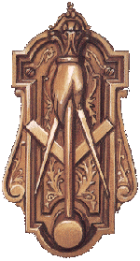Century Lodge No. 764 F. & A. M.
August 5, 2002
[Click here and type recipient’s address]
Dear Sir and Friend,
I would like to invite you to attend a program at my lodge called “Masonry’s Door” on Thursday, August 15th at 5:30 PM. This event will be held at the Cozy Restaurant at 70 N. Pennsylvania St., Indianapolis. I would consider it a personal favor to me if you would attend.
This meeting will begin at 5:30 PM with refreshments followed by the presentation from the Lodge officers. I am planning on a fun and informative event. You have received this invitation because of your personal standing and reputation in the community and I believe you to be a person who exhibits the excellent qualities that Freemasonry stands for and would be proud to be associated with publicly. Please make note that this will not be a “high pressure” sales job.
Following the Lodge’s presentation there will be an opportunity to ask questions of the Brothers. Please plan to attend! I will need your RSVP by August 13th. I look forward to meeting with you on the 15th.

Sincerely,

